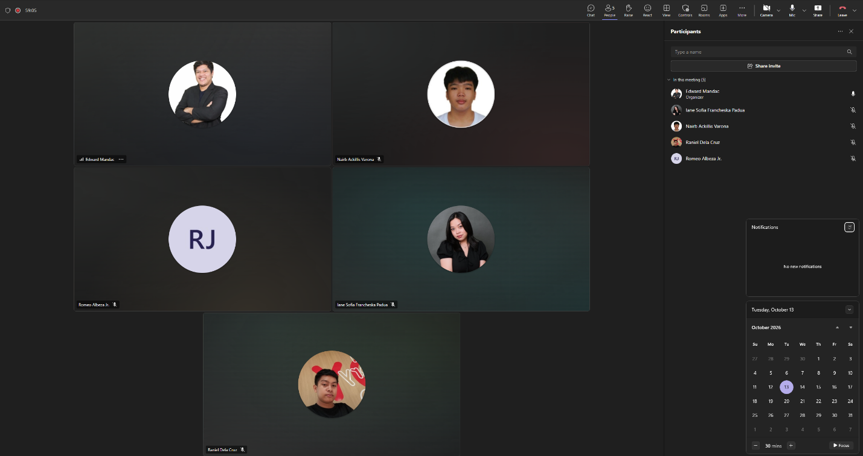
Weekly Status Report: Minutes of Meeting
- Date: Tuesday, October 13, 2026
- Meeting Called By: RRuNS Team
- Facilitator: Edward Mandac
Link of the Meeting: Recap: RRuNS - Weekly Status Meeting Tuesday, 13 October | Meeting | Microsoft Teams
- 1. Attendees
- Nairb Ackillis Varona
- Romeo Jr. Albeza
- Iane Sofia Francheska Padua
- Raniel Q. Dela Cruz
2. Agenda
- Comments of panel
- Discussion of the revision use case diagram
- Discussion of use case full description
3. Summary
- Status update for the week:
  - The team reviewed and evaluated the feedback, comments, and recommendations provided by the panel during the evaluation session.
  - Discussed the necessary updates and refinements for the revised use case diagram based on the panel's critique.
  - Covered the ongoing progress of drafting and detailing the use case full descriptions to ensure all system flows and specifications are accurate.
- Blockers/Obstacle that encountered this week:
  - Addressing and incorporating all panel feedback while managing the detailed revisions required for the use case diagram and full descriptions.

